Listening
1 3.45 Usłyszysz dwukrotnie pięć tekstów. Dla każdego tekstu zakreśl poprawną odpowiedź: a, b lub c.
1 What does the girl choose to eat?
a | b | c
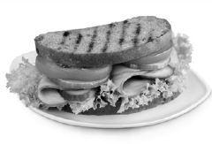 | 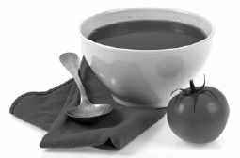 | 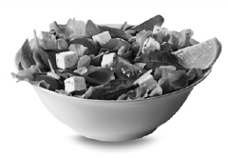
2 Where are the boy and girl?
a | b | c
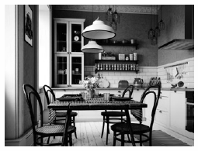 | 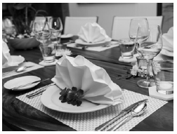 | 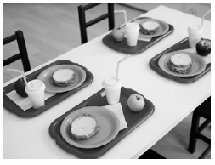
3 The girl usually eats beef stew at home with
a vegetables and rice.
b bread.
c mashed potatoes.
4 The boy can’t find a
a chopping board.
b frying pan.
c knife.
5 During the event last weekend,
a the weather wasn’t nice.
b there weren’t many people.
c the food wasn’t very good.
__ / 10
Vocabulary
2 Przetłumacz podane wyrażenia na język angielski.
polski | angielski
mikser | ¹_____________________
masło | ²_____________________
rondel | ³_____________________
groszek | ⁴_____________________
__ / 4

3 Uzupełnij zdania odpowiednimi wyrazami. Jeden wyraz nie pasuje do żadnego zdania.
butter • teaspoon • stale
spicy • roll • bowl
- You use a __________ to put sugar in your coffee.
- You can put __________ on bread to make a sandwich.
- You can use chilli to make your dish __________.
- You can put fruit on the table in a large _______________.
- Bread which is not fresh is __________.
__ / 5
Functions
4 Zaznacz odpowiednie wyrazy.
- Boil / Fry some eggs in a pan with water.
- Can you mix / chop the vegetables into small pieces, please?
- How long does it take / need to make?
- You should slice / add some spices to the soup.
__ / 4
Grammar
5 Uzupełnij dialogi odpowiednią formą czasownika be w czasie Past simple.
1
A: Paul, __________ you at home yesterday evening?
B: No, I __________. Me and my brother __________ at the cinema.

2
A: Hi, Debra. How __________ your trip to the seaside last weekend?
B: Not very good, I’m afraid. We __________ on the beach, in fact, because it __________ very cold and rainy all the time. Terrible weather!
A: Oh, poor you.
__ / 6
6 Uzupełnij zdania twierdzące (), przeczące (✗) i pytające poprawną formą wyrażenia There was / There were. Do pytań dopisz krótkie odpowiedzi.
- _______________ some cheese in the fridge. ()
- _______________ any people on the beach? Yes, _______________.
- _______________ any glasses on the table. (✗)
- _______________ a boat near the beach?
No, _______________.
__ / 6
Reading
7 Przeczytaj tekst. Zdecyduj, czy zdania 1–5 są prawdziwe (True) czy fałszywe (False) zgodnie z treścią tekstu.
Breakfast habits | ✕
Amanda, 13
The traditional English breakfast, or the 'full English', with fried eggs and sausages, bacon, tomatoes, beans and toast, is still very popular in England. But in my family we only eat it at weekends because during the week there isn’t enough time to prepare it. So, during the week we just have toast and jam, or cereal.
Paul, 12
It’s a little strange that here, in France, we like to have lots of different foods for dinner, but our breakfasts are very simple. My mum and dad usually have toast with jam or butter, or a croissant with espresso coffee, which is a very typical French breakfast. For me, that’s not enough for my day at school, so I get cheese or ham sandwiches instead.

- Many people eat the traditional English breakfast in England. | True / False
- Amanda’s family never have the full breakfast. | True / False
- Amanda’s family eat different breakfast on weekdays and at weekends. | True / False
- Paul’s parents don’t eat the typical French breakfast. | True / False
- Paul eats the same things as his parents at breakfast. | True / False
__ / 5
Writing
8 Niedawno byłeś/byłaś nad jeziorem, które chętnie odwiedzają turyści. Na swoim blogu napisz:
- z kim i jak długo tam byłeś/byłaś,
- czy było tam dużo ludzi,
- jak wyglądał teren wokół jeziora (np. czy był bardzo zaśmiecony).
Użyj maksymalnie 120 słów.
✕
Hi everyone,
I was at a beautiful lake last week.
…
That’s all for now.
__ / 10
Total: __ / 50
Extra task
9 Przetłumacz fragmenty podane w nawiasach na język angielski.
- (Jakich składników) ____________________ do I need for the dish?
- (Nie było) ____________________ many people at the concert.
- (Czy Ben był) ____________________ at school yesterday?
- Just (uspokój się) ____________________.
I will help you.
- When the meat is ready, you (możesz podać) ____________________ it with a salad or potatoes.
__ / 5
Total : ___ / 55

